TKINTER WINDOW

STARTING A BASIC TKINTER WINDOW
- import tkinter as tk
- create a root-window and initialize it within the Tk class
- Give title and geometry
- mainloop

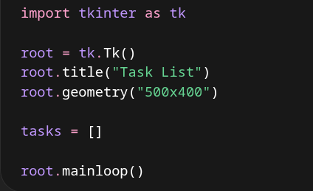

LISTBOX
- We'll use a listbox widget to display our list of tasks
- We'll initialize a listbox object, place it in our root-window, give it 40 characters of width and 10 lines of text of height
- We'll define font name and font size if needed
- We'll pack this at the top of the window and give it 10 pixels of vertical space between it and other widgets

INPUT BOX
- Use an entry widget for user entries
- Place the entry widget in the root-window and specify font name and font size
- We'll pack it to the top and give it 10 pixels of space vertically (on the y-axis)

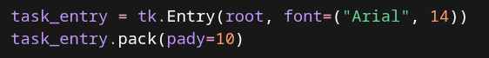

INPUT BUTTON
- This section will create a button but the button won't do anything until we connect it with a command
- Use the button widget, place it in the root-window, specify the button's functionality with "Add Task" text, and specify font name and font size if needed
- We'll pack this below the entry widget and give it 5 pixels of vertical space between it and any other widgets

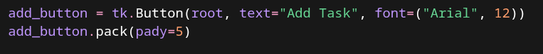

FULL CODE SO FAR

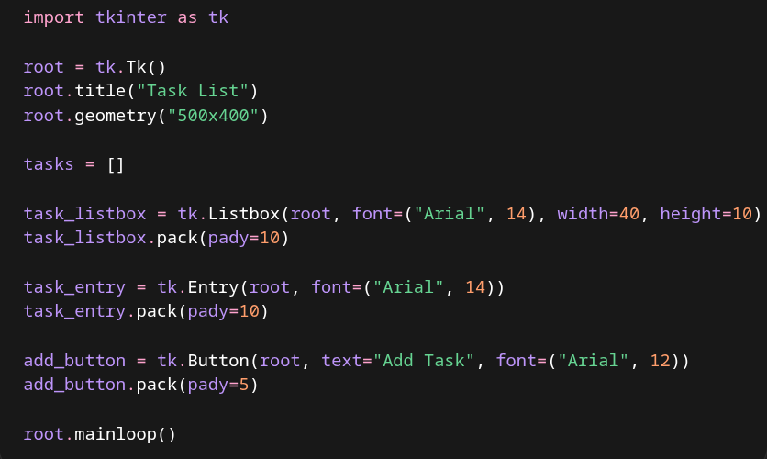

ADD TASK FUNCTIONALITY
- Next we'll create a function to connect our button with so that we can add tasks
- Define a function add_task
- We'll get the user's entry
- Create a task dictionary and set the user's entry as the description
- Append this task to our global tasks list
- Insert the task into our listbox
- Delete the user's entry

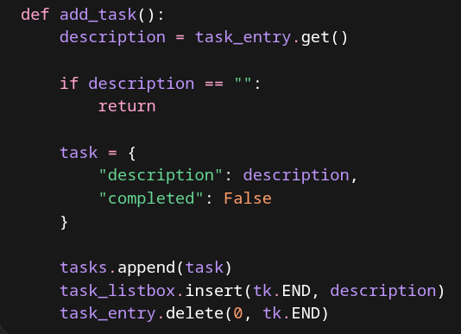

LINKING FUNCTIONS TO BUTTONS
- Next we'll link our function to our Add Task button
- Simply add the keyword argument command= with our function name add_task

BINDING ENTER TO OUR BUTTON
- We do this so that the user can press "enter" to input a task instead of clicking the button
- We will add the parameter event=None to our add_task function so that it can be called by clicking the button AND pressing "enter"
- Then add .bind( ) method to the entry widget

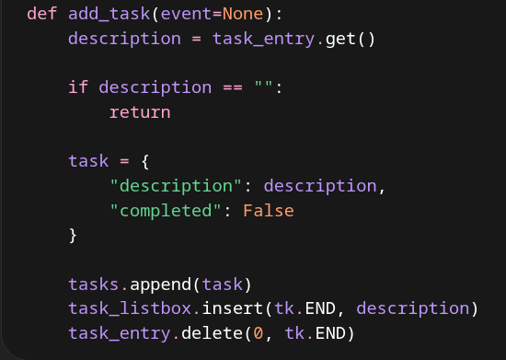

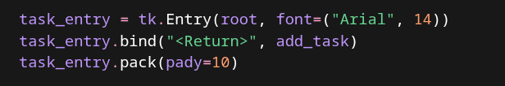

FULL CODE SO FAR

